ENS Spain Compliance for Log360
Strengthen cybersecurity and meet ENS Spain compliance with Log360.
Region: Spain | Type: Cybersecurity Framework, Government/Public Sector, Incident Management | Category: Compliance | Pricing: Free

Overview
The ENS Spain compliance extension in Log360 helps organizations meet the Esquema Nacional de Seguridad (ENS), Spain's mandatory National Security Framework established by Royal Decree 311/2022, which sets security requirements for availability, integrity, and confidentiality of government information systems by providing centralized log management, real-time threat detection, and compliance reporting. The platform supports ENS Spain requirements for access control, system monitoring, incident management, audit logging, network protection, and vulnerability management for public sector entities and their suppliers.
For op.acc.1 — Identification & Authentication, Log360 monitors logon events, failed authentications, and MFA enforcement across AD, Windows, Unix, and network devices to verify authentication controls comply with ENS requirements. To address op.acc.2 — Access Rights Management, the platform tracks group membership changes, role assignments, privilege modifications, and account management across Active Directory and cloud platforms to verify ENS access controls. The extension also supports op.acc.3 — Privileged Access Control by providing capabilities that monitors privileged group changes, password management, SUDO commands, and administrative role activities to detect privilege escalation and enforce least-privilege access.

Key Features
- op.exp.1 — Configuration Management: Log360 monitors GPO changes, registry modifications, network device configurations, and policy updates to detect unauthorized configuration changes affecting the security posture of ENS-classified systems.
- op.exp.2 — Maintenance & Change Management: Log360 tracks software installations, system updates, service changes, and program inventory to verify that maintenance activities follow authorized change management procedures.
- op.exp.6 — Protection Against Malicious Code: Log360 monitors antivirus events, malware detections, application whitelisting, and threat indicators across all endpoints from multiple security vendors.
- op.exp.8 — Audit Logging & Log Retention: Log360 collects comprehensive audit logs from Windows, Active Directory, applications, databases, and network devices providing centralized log management for ENS compliance.


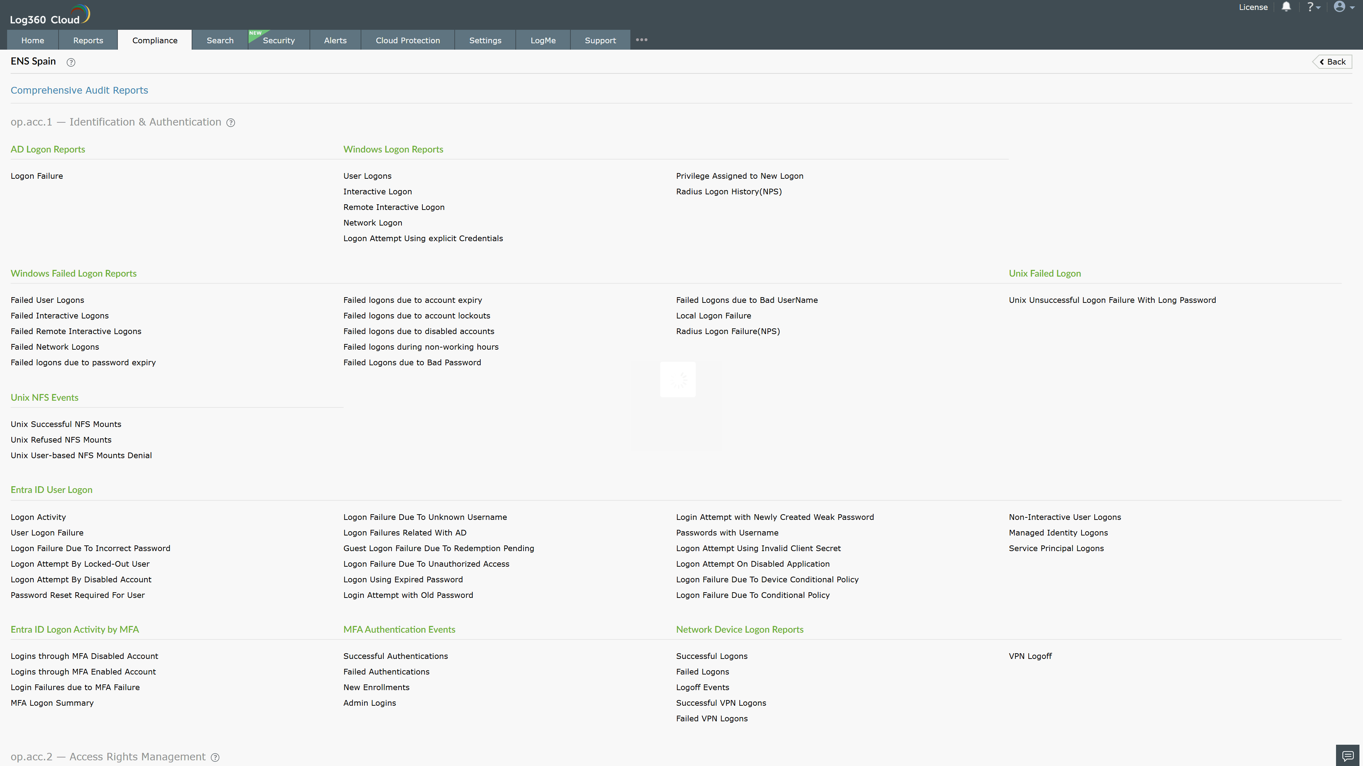
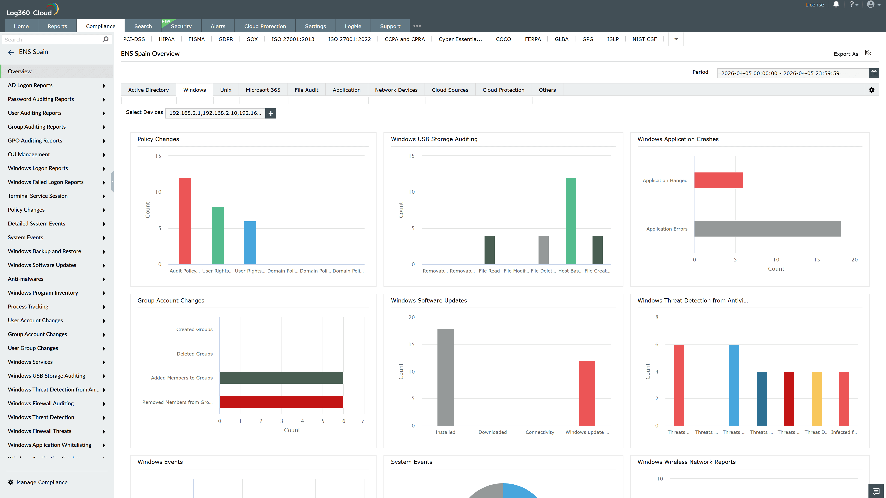
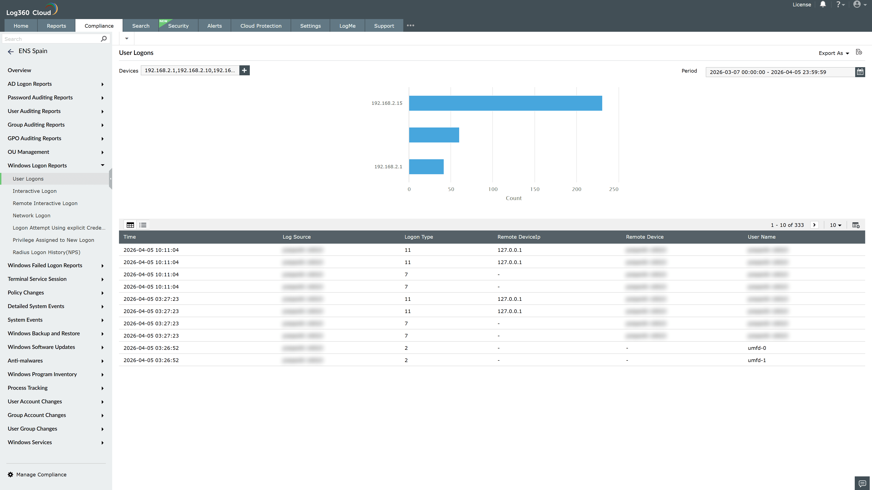
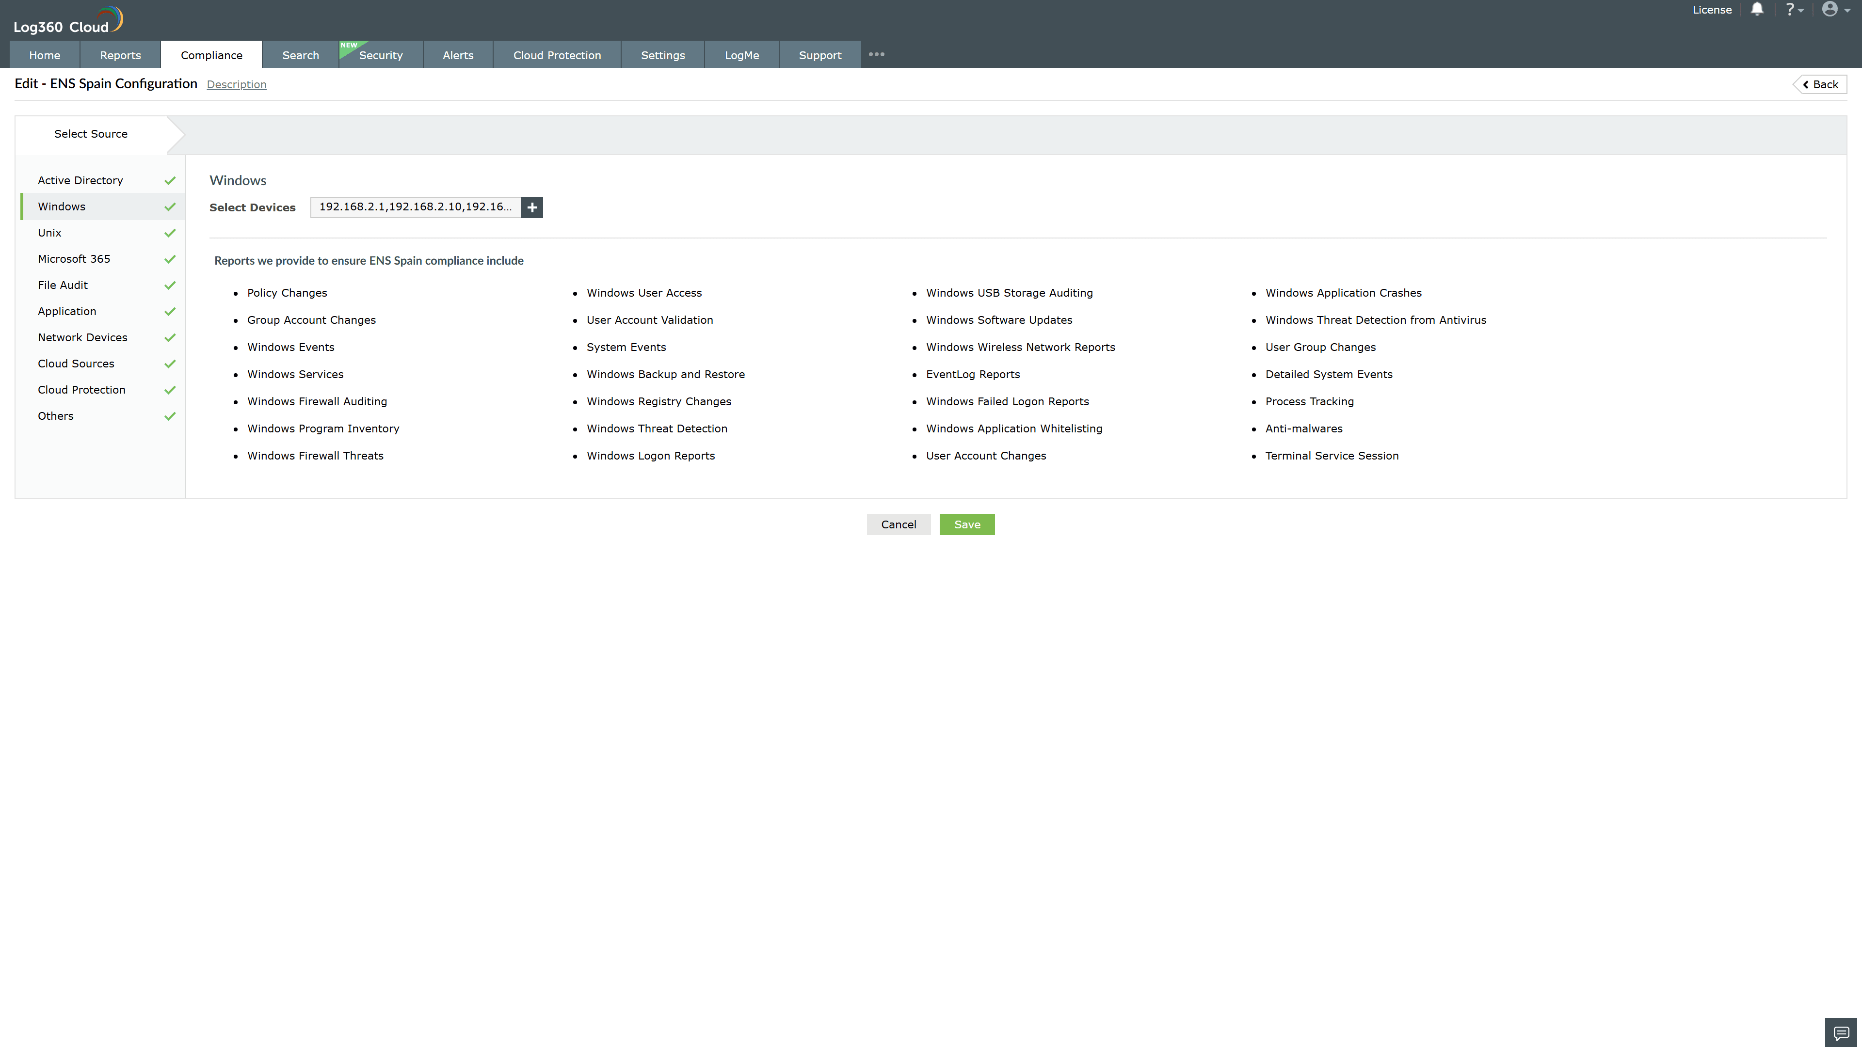
Valid Submission : Yes
Supported Editions : Free, Basic, Standard, Professional, MSSP
Help Document : https://www.manageengine.com/log-management/help/integrations/compliance-extensions.html
Help Video : Not provided
Tags : Log360, Compliance, Privacy monitoring, Data privacy, Regulatory compliance
Supported DCs : US, IN, JP, CA, AU, UK and EU
Privacy Policy:
Terms of Service:
Release Notes:
Predefined reports for the ENS Spain.

